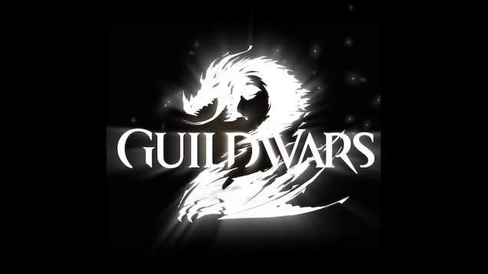

GUILDWARS 2 Guide

all useful things need to know about the event.

By Rythern Ravansson & CptWeedle

Exodus/z of the elder dragons/z [GODS]   EU based

**Intro:** Great Hall event happens about 20 minutes after finishing Palawadan meta, depending how fast you finish the raid. This is free time you can fill with some events happening on the map, giving you and your squad something to do and that little bit more loot. 2 main events to do in the meantime are described at the end of this guide. Great Hall is a siege type, very straightforward event taking place in quite confined space. Comfortable amount of people for this event is 20 and above, but you can do it with a little bit less.

On this event it’s good to remind your squad to equip a lot of CC before the start!!

**1: Break through the main gate of Mordant Crescent Great Hall**

This is the beginning of the event, it’s very straightforward. You just dps the gate and kill some enemies in front of it. Target the gate or/and tell your squad so the main target is very visible for them. You don’t need any special skills or siege equipment for that ( the map is from before Drizzlewood )

To target the gates use the games targeting system ( Crrl + click on the gate ).

2 supply caches will spawn inside on the right side in tents after you finish that event.

**2: Clear the Awakened forces from the courtyard**

Another very straightforward part of the raid, kill everything you see in front of the hall and when you see most of the enemies melted already you run with your squad doing a circle around the hall as shown on the map ( map is at the end of this guide ). That should do a trick and trigger the end of the event. Sometimes you can see some enemies standing on top of halls semi-external corridor – it’s easy to get to them by mounting up.

After finishing the event another 2 supply caches will spawn near the stairs.

**3: Defeat the Mordant Crescent Captain**

**Captain Sutekh –** his mechanics are pretty straightforward. Be careful of the ‘spinning doom’ attack. He will spin your squad in a circle and then detonate a nuke in the middle downing people probably. You can try to tell your squad to cc. Otherwise res the fallen and dps him till he dies. It’s not really that big of a deal. After the kill you run inside the corridors where you see some gears on the minimap.

2 caches will spawn on the plaza after killing him.

**4: Destroy the mesmerizing fountains of Joko**

Another really straightforward event. You run to those gears you seen on the minimap and destroy the Joko’s fountains. There is some enemies trying to make it harder for you but in most cases you can just ignore them and focus on fountains.

Another 2 caches will spawn in outer corridors after this event.

After killing all the fountains the boss will trigger. You run through the main entrance to the inside of the hall to kill Amala.

**5: Defeat Warden Amala**

Boss is pretty straightforward, you just need to take note of her phases. She will attack differently during each of them.

Lyssa phase - Mark her at the start of a fight with heart or another marker ( Ctrl + Shift + 3 ) . You will always see where she is standing even when she jumps or teleport.

Melandru phase – Big elemental spawns, you can ignore him entirely.

Dwayna phase – nothing really special here, i think it was aoe attacks.

Grenth phase – There will be a hexagon on the ground which is a soft block for you. It disappears pretty quick.

Balthazar phase – she summons meteors, they can be lethal when in aoe, try to avoid those. Jump over shockwaves.

In the meantime the Champion Mordant Enemies spawn – those drop Palawadan Phylacteries which are additional loot for your squad. You can target and focus them if you have more than 20 people in your squad and comfortable amount of time in the event left to finish the Warden herself

TLDR: Focus on Amala the more more the less time you have left. The dps phases are really straightforward. Focus on champions only if you have more time left. Control the squad with CC phrases, targeting the boss or champions and marking the boss.

After the kill caches spawn in a circle between the pillars in the hall. You have the time left to loot them and the main meta chest. After that leave the hall immediately or otherwise get nuked by ritual.

Congratulations, you just finished the Great Hall meta event. ;)

Events posted below are additional fillers for time between Palawadan and Great Hall.

**Additional events – Defend Akili**

**Defend Akili while he recalibrates telescopic mirrors around the Astralarium**

The event takes place near the **Astralarium Waypoint****.** It’s really easy to do. Just activate it on the icon you have on the minimap and follow the shield around. You will have some veterans to kill and a champion from time to time – target those champions for Phylacteries.

The last enemy which will spawn is the **Veteran Mordant Crescent Prosecutor.** Just nuke him and you are done. You can go and do your Great Hall event now. :)

**Additional events – Corsair Flotilla**

Those events taks place near the **Astralarium Waypoint****.** You go to the right from the waypoint where you can see pirate ships. Events here are really easy. It’s just kill some pirates to lure the captain out and then defeat the Captain. It’s a nice filler between Palawadan and Great Hall metas. No complicated mechanics here. :) Events change between each other a little bit ( which crew you are fighting ) but the core event itself is really easy and always the same.

The numbers on the map correspond to the numbers of the events described above so for example number 1 is to kill the gate and so on. ;) Good luck!

